For Immediate Release
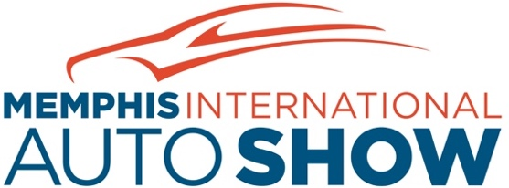

2022 Memphis International Auto Show Returns to Renasant Convention Center -- Admission to Show is FREE This Year

Hundreds of New Model Vehicles, Ford’s Outdoor EV Track and More

MEMPHIS, Tenn. (April 7, 2022) -- Featuring hundreds of new vehicles, pre-production models, luxury vehicles, all electric vehicles and more, the 2022 Memphis International Auto Show will offer free admission this year, compliments of the Greater Memphis Auto Dealers Association. The auto show will return to the Renasant Convention Center, Friday, April 22, to Sunday, April 24, 2022, after being canceled the last two years due to the COVID pandemic. Car lovers are invited to check out hundreds of the latest vehicles in a non-selling environment, inspect engines, experience the latest automotive technology, and even go for a test drive – all for free.

Ford Motor Company, which just last year announced it would invest $5.6 billion to build its largest, most advanced, and most efficient auto production campus in its history in West Tennessee, will make a big splash at the Memphis International Auto Show. Indoors, attendees will find the latest Ford electric vehicles like the all-new Ford F-150 Lightning, Mustang Mach-E and E-Transit. Outside, Ford’s Built to Electrify drive track will pair show-goers with professional drivers for a trip around the track in an F-150 Lightning or Mustang Mach-E, showcasing the strength, capability, connectivity, and instant torque of Ford’s exciting lineup of fully electric vehicles.

Car fans can also test drive an assortment of vehicles outside the convention center from Chrysler, Dodge, Jeep and Ram. This year’s auto show will also feature Subaru Pet Adoptions all show days. Pets looking for forever homes will be available for adoption in Subaru.

Additionally, product specialists from leading automotive manufacturers will be at the show to answer questions and provide information on the latest vehicles. A must-see lineup of pre-production models, not yet available in dealer showrooms will be on the show floor including the 2023 Subaru Solterra (EV), 2022 Grand Wagoneer, 2022 Jeep 4xe (hybrid), 2022 Ford F-150 Lightning (EV), 2022 Toyota Corolla Cross, 2022 Toyota Tundra, 2022 Chevrolet Corvette, 2022 Chevrolet Bolt and 2022 Ford Bronco, to name a few.

The 2022 Memphis International Auto Show is owned and presented by the Greater Memphis Auto Dealers Association and produced by Steve Freeman Events. The show will be open to the public Friday, April 22 through Sunday, April 24, at the Renasant Convention Center, 255 North Main Street, Memphis Tennessee, 38103. Show hours are Friday, and Saturday 10 a.m. to 7p.m. and Sundays 10 a.m. to 5 p.m.

Admission to the auto show is FREE this year, compliments of the Greater Memphis Auto Dealers Association.
For more information visit Memphis International Auto Show. Follow @MemphisAutoShow on Facebook and @MemphisAutoShow on Instagram.

CONTACT:
DeeDee Taft
Spin Communications
o) 415/380-8390, m) 415/515-1229
deedee@spinpr.com
# # #

